Daniel Ngo, Arjun Ganesan

ECE 4273 – Digital Design Lab

November 19, 2021

**ECE 4273 Final Project Preliminary Report – Digital Clocks**

1. **General Purpose**

The purpose of this project is to implement a digital clock that keeps track of the time of day and an alarm clock value, both of which are displayed on an LCD module and configurable by the user using a 4x4 keypad. When the alarm time is reached by the clock, a melody alarm sounds, and on the 00, 15, 30, and 45 minutes past the hour, the appropriate sections of the Westminster chimes are played. We plan on displaying the time of day as well as the alarm time using an LCD module with a HD44780 controller, using a multiplexed switch keypad to allow user input to set the time of day and alarm clock time, and the LPC1769’s built in Timer, Alarm, and PWM modules to implement the time-of-day clock, the alarm clock, and the alarm and chimes sounds.

Below is a list of functions and features of the circuit, along with their point value:

|  |  |
| --- | --- |
| **Feature** | **Points** |
| Time of Day | 1 |
| Alarm Clock | 1 |
| Chimes | 1 |
| Melody Alarm | 0.5 |
| Serially Controlled Display (I2C) | 0.5 |
| Character LCD w/ HD44780 | 0.5 |
| Keypad | 0.5 |
| TOTAL | 5 |

1. **Design Analysis – Component Values and Configuration**
   1. **4x4 Multiplexed Switch Keypad**

The multiplexed switch keypad is configured as active-low. We drive the selected row low and the others with high impedance to determine the correct row and column of the selected key.

* 1. **LM386 Audio Amplifier**

For our audio amplifier, we use a 10kOhm-1kOhm voltage divider on the input, 100nF capacitors to the LM386 audio amplifier (Bypass (Pin 7) to GND, Vs (Pin 6) to GND (Pin 4), Vout (Pin 5) to GND (Pin 4)). We also have a 1mF load capacitor (Vout (Pin5) to Speaker). See the hardware schematic for more details.

* 1. **Character LCD w/ HD44780**

To interface between the LCD and the LPC1769, we use an MCP23017 I/O expander using I2C. To find our lower bound for the SDA and SCLK pull-up resistor value, we consider weakest device $I_{OL}$ parameter: 3.0mA (SDA in MCP23017). Thus, our lower bound for R:

$$R>\frac{V_{DD}}{I_{OL}}=\frac{3.3V}{3.0mA}=1100Ω$$

Setting the PCLKSEL0’s bit 14 and 15 to 00, and choosing I2C0SCLH=I2C0SCLL=5 to obtain an I2C frequency of 100kHz and 50% duty cycle, we chose a I2C clock value to be:

$$f_{I2C}=\frac{CCLK/4}{(I2C0SCLH+I2C0SCLL)}=\frac{1MHz}{10}=100kHz$$

Finding the upper bound for our pull-up resistor, and checking that $t_{r}≪t_{cycle}$:

$$R≪\frac{t_{cycle}}{3C}=\frac{1}{3fC}=\frac{1}{3\left(100kHz\right)\left(3∙10pF\right)}=1.11MΩ$$

$$t_{r}≈3RC=3\left(10kΩ\right)\left(3∙10pF\right)=90ns≪1μs=\frac{1}{f_{I2C}}=t_{cycle}$$

Thus, our pull-up resistor value $R=10kΩ$ satisfies the lower bound and upper bound.

1. 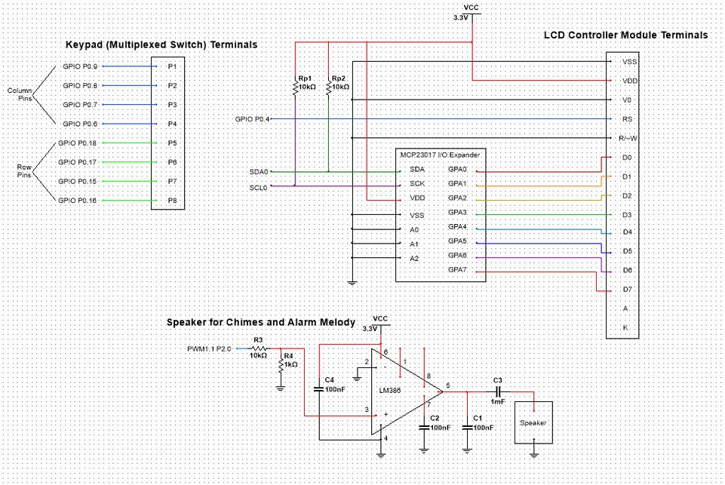**Hardware Schematic**
2. **Description of Software Plan**

We are planning to implement our software to use the LPC1769’s built-in timer and alarm timer modules to keep track of the time and alarm time. The LPC1769’s PWM and Digital-to-Analog subsystem will be used to generate the sounds needed for the chimes and melody alarm. We will use I2C to interface with the LCD and interrupts to handle keypad inputs.